# Project Design Phase-I Solution Architecture

|  |  |
| --- | --- |
| Date | 21 September 2023 |
| Team ID | NM2023TMID3960 |
| Project Name | Project – Central Bank Management |
| Maximum Marks | 4 Marks |

**Solution Architecture:**

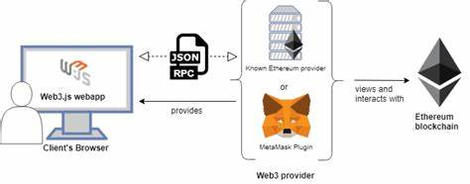

**GENERAL ARCHITECTURE**

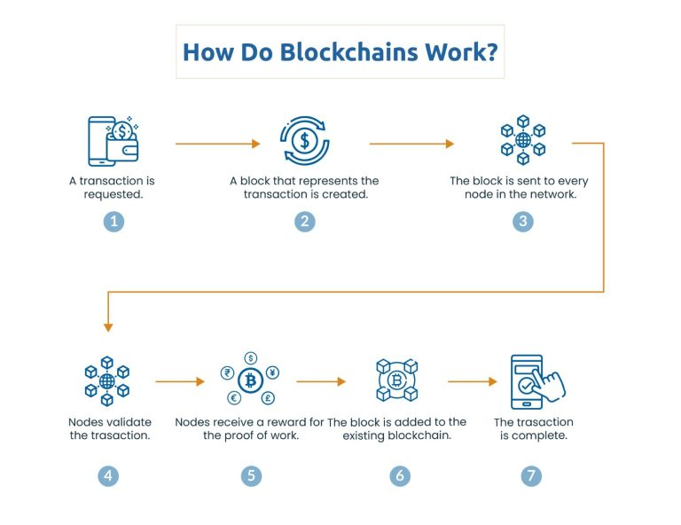

**FLOW OF TRANSACTIONS**